**Question :**

Which of the following are red-black BST?

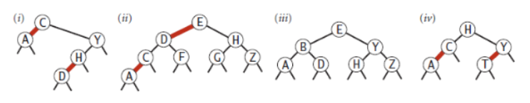

**Solution :**

The Red-Black trees have the following main rules :

* Every node has a colour either a red or a black
* The root of a tree is always black
* No two adjacent nodes are always red
* Every path from a node (including root) to any of its descendant NULL node has the same number of black nodes.

According to the rules, the red-black trees from the following list are :

1. Not a Red-Black BST, since the number of black nodes from the root node to the Null nodes is not the same in every case.
2. Not a Red-Black BST, since the number of black nodes from the root node to the Null nodes is not the same in every case.
3. It is a Red-Black BST, as it satisfies all the rules.
4. It is a Red-Black BST, as it satisfies all the rules.